Design and Tuning Methodology for PID Control of Parallel Flow Control Valves

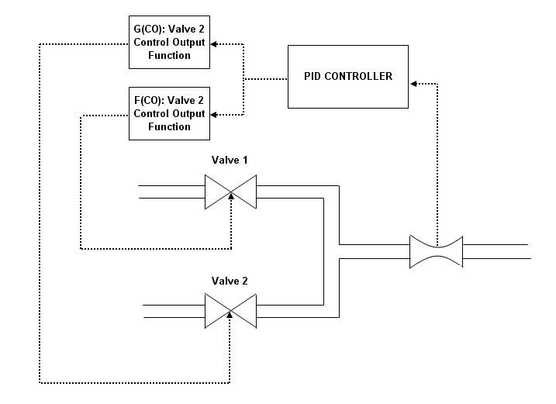
Figure 1: Block Flow Diagram of Parallel Flow Control Valve Control Scheme

Many of the flow controllers used on TAPS have their control output sent to two sets of valves which are different sizes and have different Cv curves. This paper contains a suggested methodology for the design and tuning of the controller for this set up.

Traditionally we have programmed these controllers so the lower valve opens up first while the larger valve remains closed. Once the smaller valve reaches 100% open the controller switches to controlling the larger valve. This has often resulted in poor control in the range where the control is switched between the two valves.

Theory

We want design the controller so that on of the valves will be between 25 and 75 % open for the maximum amount of control space. This can be accomplished by splitting the control region into 3 phases; the first is between

The controller will be designed so that the steady state response will be:

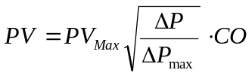

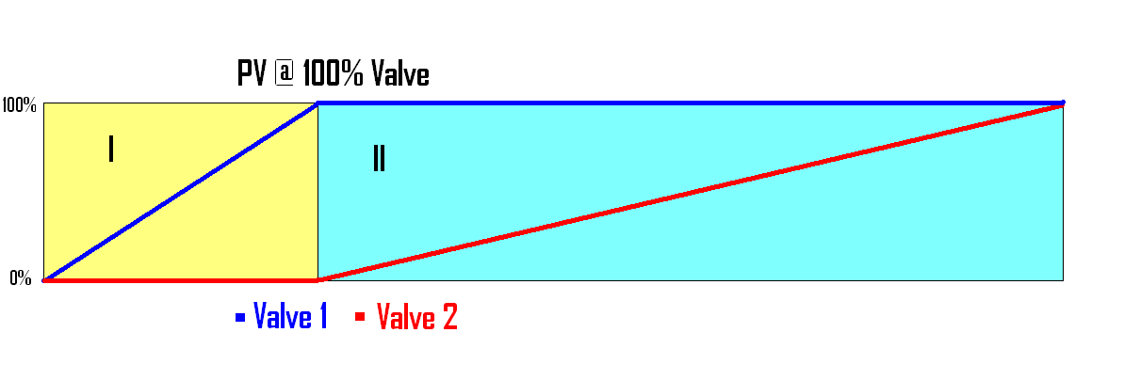
Figure 2: Diagram Representing the Original Approach
Region 1: Valve 2 is 0% Open and the controller is actively controlling Valve 1
Region 2: Valve 1 is 100% open and the controller is actively controlling Valve 2
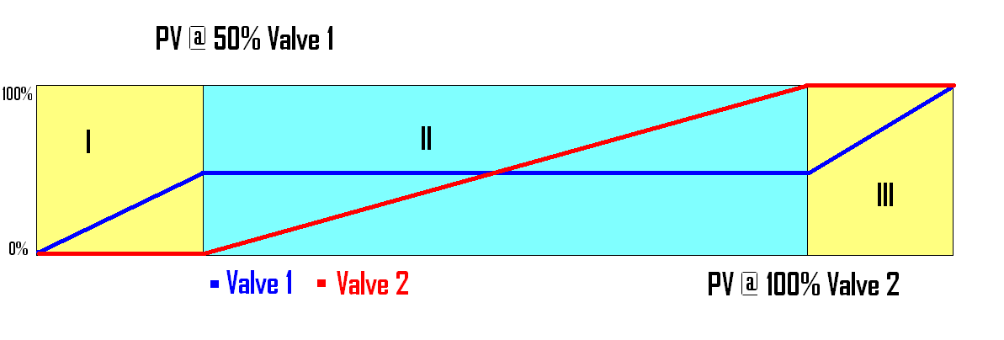
Figure 3: Diagram Representing the New Approach
Region 1: Valve 2 is 0% Open and the controller is actively controlling Valve 1
Region 2: Valve 1 is 50% Open and the controller is actively controlling Valve 2
Region 3: Valve 2 is 100% Open and the controller is actively controlling Valve 1

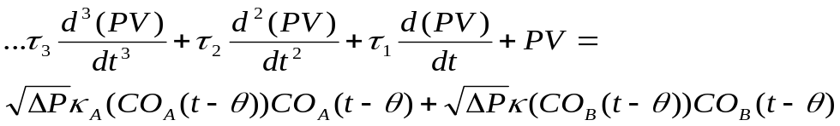

At Steady State:

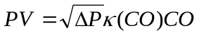

Desired Response:
Finish first draft of this on wed.

Paper Organization

- Manipulating the Control Output to balance out flow steady state control valve non-linearity
- Designing the parallel valve controller to avoid poor transfer of flow control between the two valves
- Using (1) and (2) to create a standard method for design and tuning of flow controllers which use parallel control valves

At steady state:

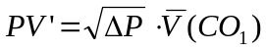* See appendix A for details
Since 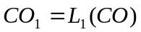

I if 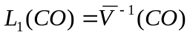

Then 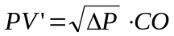

In application we need to plot the process variable at steady state vs. the corresponding control output and find a reasonable fit for the data.

APPENDIX A

For any function 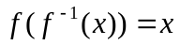

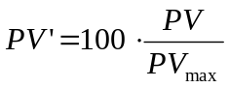
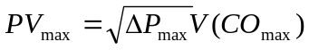

e.g. In the case where Q is our PV,

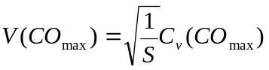

Now define the following function V’(CO)

